For Registrar
Use Only
Children’s Costume Contest
Registration Form

On the stage at Depot Park in Historic Downtown Russellville

Saturday October 30,2021
Registration 9:30 a.m. - 10:30 a.m. (no late entries accepted)
Contest Begins promptly at 11:00 a.m.

Child’s Name:___________________________________________________

Parent’s/Guardian’s Name:________________________________________

Child’s Age:_________ Parent Cell Number:_______________________

Costume Description:_____________________________________________
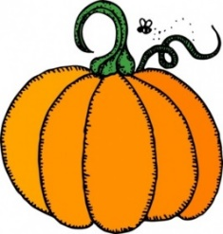
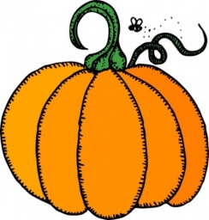

Please check the appropriate age group:

0-12M_____ 13 M-2yr_____ 3yr-4yr_____ 5yr-7yr_____ 8yr-12yr_____

Prizes will be awarded by age group.

I give my permission for my child to be photographed during the Children’s Costume Contest.
I understand photos may or may not appear in Fall Fest publicity.

___________________________________________
Parent/Guardian Signature

Sponsored By
Junior Auxiliary of Russellville, Inc.

