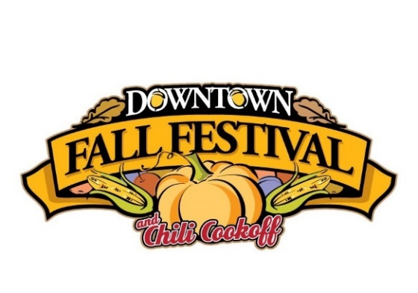
RESERVATION FORM

Saturday, October 30th, 2021
Downtown Historic District
Russellville, Arkansas

Due to Covid-19, we will not be accepting payment for exhibit spaces until September 1st. This form allows you to reserve your space and helps us plan for the event. You will be notified if we must cancel the event due to Covid-19. Please let us know ASAP if you are unable to attend. All payments must be made by September 30th to secure your exhibit space. We will contact you before September 1st to complete registration and secure payment.

Arts & Crafts Exhibit Space (table, chairs, tent NOT included) 10’x10’ = $75.00
Nonprofit Exhibit Space (table, chairs, tent NOT included) 10’x10’ = $75.00
Political Exhibit Space (table, chairs, tent NOT included) 10’x10’ = $200.00
Commercial Exhibit Space (table, chairs, tent NOT included) 10’x10’ = $150.00
Commercial Food Exhibit Space 10’x15’ and (1) 110 volt/20 amp circuits= $250.00

*Commercial Food Exhibit Spaces will be given first priority with electrical access, but if spaces are available, other vendors can pay an additional $25.00 per 110 volt/20 amp circuits*

Type of Exhibit Space: ____________________________________________________

Business Name:_________________________________ Contact Name:__________________________

Mailing Address:_________________________________City:______________State:_____Zip:________

Business Phone: _________________Other Phone:_________________ E-mail: ____________________

Website: _______________________________________ Tax ID # (if applicable):___________________

Please list the craft, commercial, and/or food items that you intend to exhibit:

_____________________________________________________________________________________
For additional information, please call the Main Street Russellville office at (479) 967-1437.
Please make checks for registration payable and mail with completed application to:
Main Street Russellville, P.O. Box 694, Russellville, AR 72811

EXHIBITOR REGISTRATION SHOULD BE SUBMITTED AND PAID FOR NO LATER THAN SEPTEMBER 30TH
My signature verifies that I have read and understand this agreement of participation:
(Make a copy of this signed document for your records)

___________________________________________________________________________
PRINT NAME SIGNATURE DATE

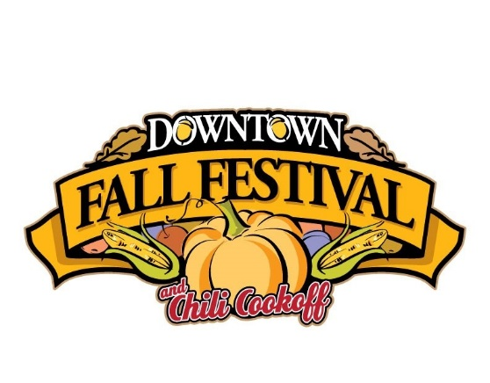
SATURDAY OCTOBER 30TH 2021
HISTORIC RUSSELLVILLE DOWNTOWN
RUSSELLVILLE, ARKANSAS

CONTACT INFORMATION:
mainstreetrussellvillear@gmail.com
479-967-1437

AGREEMENT OF PARTICIPATION

*Each exhibitor/vendor will be assigned a booth space in Russellville Downtown. Spaces will be assigned based on the exhibitor and as existing infrastructure allows (water, electric, etc.). Assignments are totally at the discretion of the Fall Fest Staff. Space assignment requests will not guaranteed.

*All commercial food vendor spaces will be assigned based on electrical needs and determination of event staff on best placement practices for our event.

*A space will not be assigned or reserved until FULL PAYMENT (check or cash) is received from a vendor.

*A $25 fee will be added to registration for each 110 outlet requested by exhibitors.

*Vendors are responsible for needed supplies (tent, umbrella, heavy 100 ft. extension cords, tables, chairs, coverings, etc.).

*Vendors are responsible for making sure all trash in or around their space is discarded in an appropriate receptacle.

*Set up the morning of the event is from 6am-9am. All exhibits must be set up by 9am and remain until 5pm the day of the event. The streets will be closed to all traffic (excluding foot traffic) at 9 am and will not re-open until 5pm.

*Festival staff will be stationed at entrance locations for check in at set up. Your entrance and set up information will be sent to you prior to the event. After set up, you will exit the festival area through your designated exit.

*Main Street Russellville is a 501(c)(3) non-profit organization that reserves the right to sell Coca-Cola soft drink and bottled water products at our event. Exhibitors/vendors shall not sell or give away Coca-Cola products or bottled water.

*Russellville Downtown Fall Fest is a RAIN OR SHINE event. Refunds will not be given due to inclement weather. The event will only be cancelled in the event of dangerous weather.

*For more information, please contact the Main Street Russellville office.

We are excited to have you join us for our 30th Annual Russellville Downtown Fall Festival!

