For Registrar
Use Only
Pumpkin Decorating Contest
Registration Form

On the stage at Depot Park in Historic Downtown Russellville

Saturday October 30th, 2021
Pumpkins on stage by 10am (no late entries accepted)
Place form face down under pumpkin
Winners announced on stage at 11:00 a.m.

Child’s Name:___________________________________________________

Parent’s/Guardian’s Name:________________________________________

Child’s Age:_________ Parent Cell Number:_______________________

Pumpkin Description:_____________________________________________

_________________________________________________________________

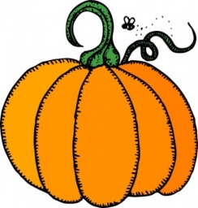
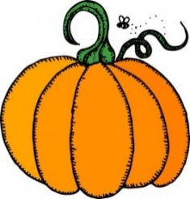
I give my permission for my child to be photographed during the
Pumpkin Decorating Contest.
I understand photos may or may not appear in Fall Fest publicity

___________________________________________
Parent/Guardian Signature

Sponsored By
